**Obituary**

Sleep In Peace- Midnight Flower Delivery in Category | Flowers | Sympathy Flowers -This beautiful flower arrangement contains: 10 Stem White Lily 20 White Carnation 20 White Rose 5 Stem White Daisy Seasonal fillers Some of the Lilies may arrive in bud form, ready to bloom into full beauty in 2-4 days. Lily color will be replaced with best available color of equal value. While we always strive to ensure that products are accurately represented in our photographs, from season to season and subject to availability, our florists may be required to substitute one or more flowers for a variety of equal or greater quality, appearance and value.  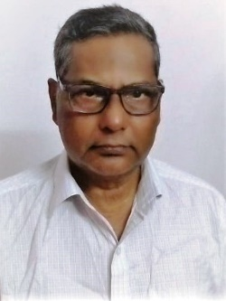 Emotions- -This beautiful flower arrangement contains: 40 White Carnation 20 Red Carnation Seasonal fillers   While we always strive to ensure that products are accurately represented in our photographs, from season to season and subject to availability, our florists may be required to substitute one or more flowers for a variety of equal or greater quality, appearance and value. 

Very sorry to mention the sudden demise of Dr.YH Rao, on 25th September 2022 at Hyderabad. Very Knowledgeable person and was keen to take astro classes at JKRARF. It is a great loss to entire fraternity of astro world. A wonderful scholar and keen learner of astrology. Our heartfelt condolences to his family members. May his atma attain Sathgadi.

Dr. YH Rao, have started his career with SSC & ITI in a private industry, later joined in Central Govt. Job as a Technician. While working he completed Inter & BSc through night college and completed his MSc (App Phy) and continued in private industrial sector as Development Engineer, Purchase Executive, Stores Officer, Asst. Mgr (Matls). In this duration he completed GDMM (IIMM).

He entered into the teaching field and continued till to attaining the superannuation age. He taught for Inter, BSc, Post Diploma in Instrumentation in Govt. Polytechnic, and then in Private Engineering Colleges. While working in teaching, he completed MPhil, PhD (Phy), MTech (ECE), MBA (HR).

It made him join in MA (Jyothisa), PSTU, and then he joined with JKR and completed MA & PhD (Vedanga Jyothisa) from Yoga Samskrutham University, Florida, USA and has been associated with JKR family.